**Lesson 15**

**Objectives**

* Enhanced ERD
  + Super Type
  + Sub Type
  + Generalization
  + Specialization
  + Attribute Inheritance
  + Relationship Inheritance
  + Constraints
    - Completeness Constraint
      * Total Specialization
      * Partial Specialization
    - Disjoint Constraint
      * Disjoint Rule
      * Overlap Rule

**Enhanced ERD**

The model that has resulted from extending the original ER model with new modeling constructs.

**Super Type**

A generic entity type that has a relationship with one or more subtypes

**Sub Type**

A sub grouping of the entities in an entity type that has attributes distinct from those in other subgroup.

In the figure below a generic representation of super type and sub type is given. Sub types will exist on the base of unique attributes. If there will be no unique attributes the there will be no sub group. In the figure there is one super type; on the base of unique attributes there will be some subgroups (sub types).

**Generalization**

The process of defining a more general entity type from a set of more specialized entity types. BOTTOM-UP.

Generalization is done on the base of common attributes

**Example**:

Consider the following scenario of vehicle:

There are three types of vehicle car, truck, and motorcycle as modeled in figure below

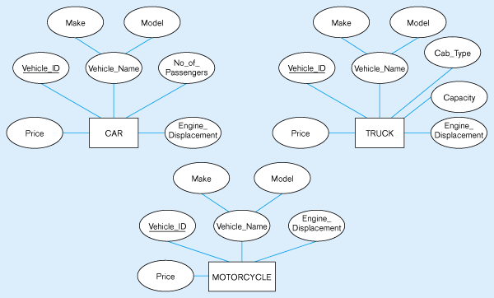

If we analyze the scenario (figure) carefully; we will conclude that there are some common attributes in each (car, truck, and motorcycle) entity. On the base of common attributes we can create a super type and on the base of distinct attributes we can create sub groups as in figure below.

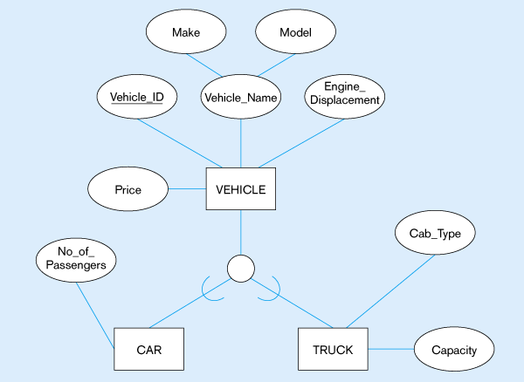

On the base of common attributes we have created a super type (vehicle) and on the base of distinct attributes; two sub groups (car and truck is created). There is no distinct attribute for motorcycle; therefore no sub group for motorcycle is created.

In this process we have created a generalized concept (vehicle) from some specialized concepts (car, truck, and motorcycle); so this is called generalization.

**Specialization**:

The process of defining one or more subtypes of the supertype and forming supertype/subtype relationships. TOP-DOWN

Specialization is done on the base of some distinct attributes.

**Example 1**

Consider the following scenario of Employee

**Employee**

In the above example salary is a distinct attribute for permanent employee only and hourly rate is an attribute that is only for visiting employee.

On the base of these distinct attributes (salary, hourly rate) two subgroups (visiting employee and permanent employee) can be created as follow.

Visiting Employee

Permanent Employee

**Employee**

In the above scenario we have made two subgroups on the base of distinct attributes; this process is called specialization.

**Example 2**

Consider the following scenario

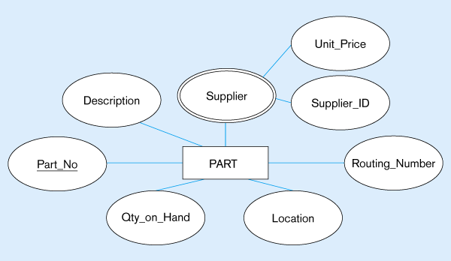

Only applies for manufacture part

This only applies for purchased prat

on the base of purchased part and manufactured part we have to made two

subgroups as follow

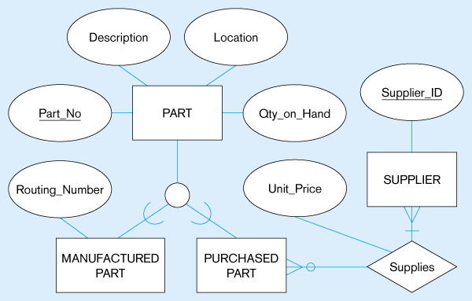

**Attribute Inheritance**

* + Subtype entities inherit values of all attributes of the super type
  + An instance of a subtype is also an instance of the super type

As in figure below; it is mentioned that attributes of super type will be share by all entities.

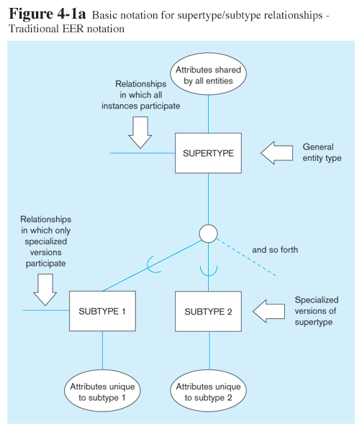

**Relationships and Subtypes**

* Relationships at the ***supertype*** level indicate that all subtypes will participate in the relationship
* The instances of a ***subtype*** may participate in a relationship unique to that subtype. In this situation, the relationship is shown at the subtype level

In other words:

* If any other entity has relationship with subtype then this will only for that subtype.
* If any other entity has relationship with super type then this will also for subtypes.

As in figure above it is mentioned that all instances of super type and subtype will participate in relationship that exist with super type. But in relationship that exist with subtype is only for that particular subtype.

**Example**:

Above discussed concepts can be understood more clearly by following example.

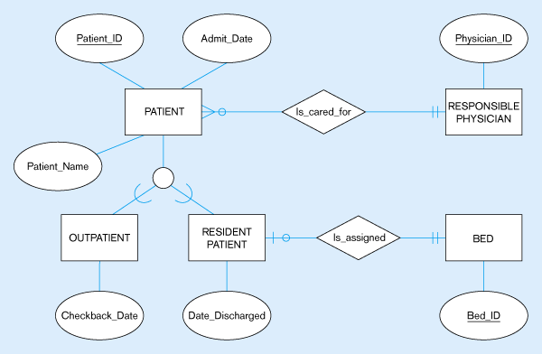

In this example; Patient is super type and outpatient & resident patient are two subtypes. These two subtypes are due to distinct attributes checkback_Date &Date_discharged. All attributes (patient_name, patient_id, admit_date) will be the attributes of each sub groups (outpatient, resident patient).

Super type is making a relationship (is_cared_for) with some other entity; so this relationship will also exist for both sub groups (outpatient, resident patient).

Subtype (resident patient) also making a relationship (is_assigned) with some other entity; this relationship exist only for this sub group (resident patient).

**Completeness**

* Whether an instance of a supertype ***must*** also be a member of at least one subtype
  + Total Specialization Rule: Yes (double line)
  + Partial Specialization Rule: No (single line)

Partial Specialization Example

**Disjointness**

* Whether an instance of a supertype may *simultaneously* be a member of two (or more) subtypes
  + Disjoint Rule: An instance of the supertype can be only ONE of the subtypes
  + Overlap Rule: An instance of the supertype could be more than one of the subtypes

Disjoint Rule Example

Overlap Rule Example